Name: Nkwine Innocent

Student Number: 1901200153

Assignment one (RMI application that adds, divides, multiplies and subtracts integers supplied by the user)

**Remote interface**

package workinterface1;

/**

*

* @author NKWINE INNOCENT

*/

import java.rmi.Remote;

import java.rmi.RemoteException;

public interface wokinterface extends Remote{ **// Creating Remote interface for the application**

public int calculate(int a,int b,int choice) throws RemoteException;

}

**Implementation of the interface (implementation class)**

package workimp1;

import java.rmi.RemoteException;

import java.rmi.server.UnicastRemoteObject;

import workinterface1.wokinterface;

/**

*

* @author NKWINE INNOCENT

*/

**// implementing the remote interface**

public class workimp extends UnicastRemoteObject implements wokinterface{

public workimp() throws RemoteException

{

}

**// implementing the interface method**

public int calculate(int a, int b, int choice) throws RemoteException {

int result=0;

switch(choice)

{

case 1:

result =a+b;

break;

case 2:

result =a-b;

break;

case 3:

result =a*b;

break;

case 4:

result =a/b;

break;

default:

System.out.println("Invalid choice");

break;

}

return result;

}

}

**Server Program (server class)**

package workserver1;

import java.rmi.registry.LocateRegistry;

import java.rmi.registry.Registry;

import workimp1.workimp;

/**

*

* @author NKWINE INNOCENT

*/

public class workserver {

public static void main (String[ ]args) **// instantiating the implementation class**

{

try

{

Registry reg=LocateRegistry.createRegistry(1099); **// port number**

reg.rebind("calc", new workimp()); **//exporting the object of the implementation class**

System.out.println("Server ready.......");

}

catch (Exception ex)

{

ex.printStackTrace ();

}

}

}

**Client Program (client class)**

package workclient1;

import java.io.BufferedReader;

import java.io.IOException;

import java.io.InputStreamReader;

import java.rmi.Naming;

import workinterface1.wokinterface;

/**

*

* @author NKWINE INNOCENT

*/

public class workclient {

public static void main(String[ ]args) throws IOException

{

try{

wokinterface c= (wokinterface)Naming.lookup("rmi://localhost:1099/calc"); **// Bind the localhost with the service**

BufferedReader br=new BufferedReader(new InputStreamReader(System.in));

int n1,n2,ans;

int choice;

do

{

System.out.println("CALCULATION MENU");

System.out.println("----------------------");

System.out.println("Enter 1 for addition");

System.out.println("Enter 2 for subtraction");

System.out.println("Enter 3 for multiplication");

System.out.println("Enter 4 for division");

System.out.println("Enter 5 to exit");

System.out.println("\n"+"Enter your choice: ");

choice=Integer.parseInt(br.readLine());

if(choice==5)System.exit(0);

if(choice<=0 || choice>5)System.exit(0);

if(choice>0 && choice<5)

{

System.out.println ("Enter first number");

n1 =Integer.parseInt(br.readLine());

System.out.println("Enter second number");

n2 =Integer.parseInt(br.readLine());

ans=c.calculate(n1, n2, choice); **// calling remote method using the obtained object**

System.out.println ("----------------------");

System.out.println("Processed result is: "+ans);

}

}while(true);

}

catch(Exception ex)

{

ex.printStackTrace();

}

}}

Remote interface

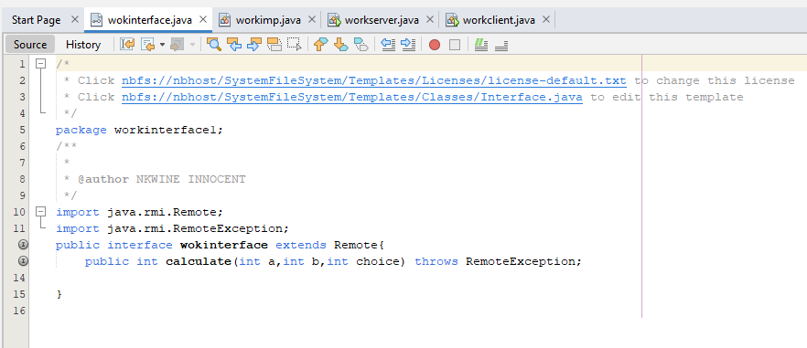

Implementation of the interface

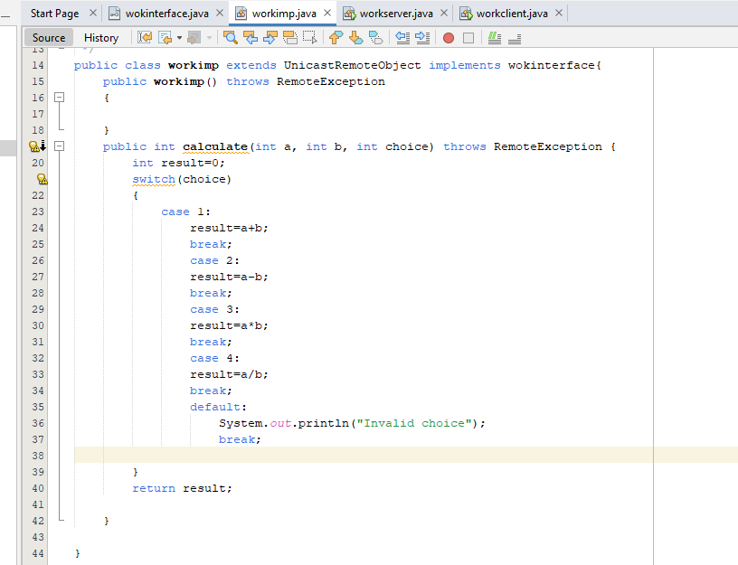

Server program

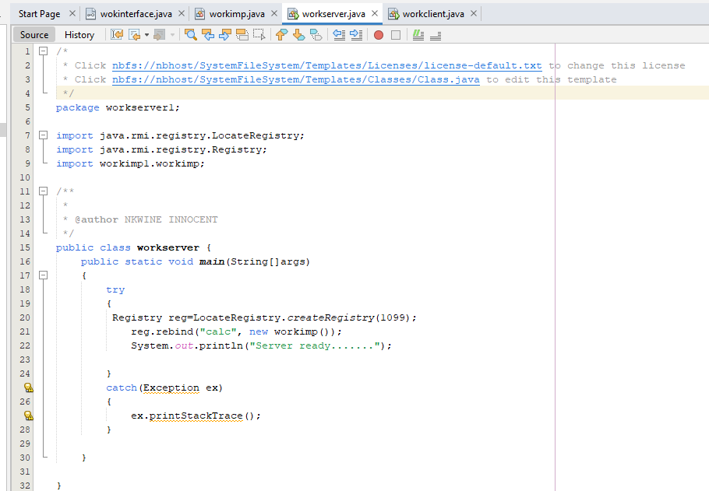

Client program

